**P1: Write a program to draw a pattern given below from 0-100.**

**E.g. if n==5**

**\*\*\*\*\***

**\*\*\*\*\***

**\*\*\*\*\***

**\*\*\*\*\***

**\*\*\*\*\***

var n = 5;

var str = "";

for(i = 0; i <n; i++){

for(j =0; j < n; j++)

{

str += "*"

}

str += "\n"

}

console.log(str);

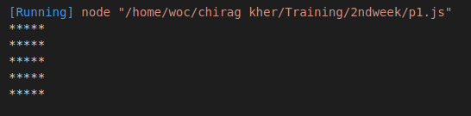

**P2: Write a program to draw a pattern given below from 0-9.**

**E.g. if n==5**

**12345**

**12345**

**12345**

**12345**

**12345**

var n = 2;

var str = "";

for(i = 1; i <n+1; i++){

for(j =1; j < n+1; j++)

{

str += j;

}

str += "\n"

}

console.log(str);

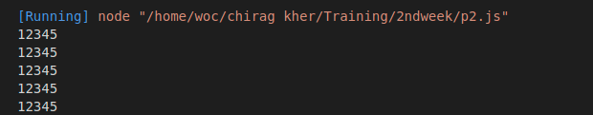

**P3: Write a program to draw a pattern given below from 0-9.**

**E.g. if n==5**

**11111**

**22222**

**33333**

**44444**

**55555**

var n = 6;

var str = "";

for(i = 1; i <n; i++){

for(j =1; j < n; j++)

{

str += i;

}

str += "\n"

}

console.log(str);

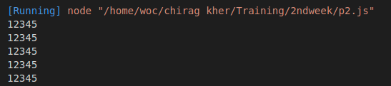

**P4:** Write a program to draw a pattern given below from 0-9.

E.g. if n==5

*

**

***

****

*****

var str = "";

var n = 5

for(i = 0; i < n; i++){

for(j =0; j <=i; j++){

str += "*"

}

str += "\n"

}

console.log(str);

**P5:** Write a program to draw a pattern given below from 0-9.

E.g. if n==5

*

**

***

****

*****

var n = 7

var str = ""

for(i = 0; i <=n; i++){

for(j = 0; j <= n; j++){

if( i + j <= n)

{

str += " "

}else{

str += "$";

}

}

str += "\n"

}

console.log(str);

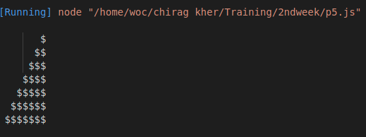

**P6:** Write a program to draw a pattern given below from 0-9.

E.g. if n==5

1

121

12321

1234321

123454321

var str = ""

var n = 5

for(i = 0; i < n-1; i++){

for(j = -4; j < n-1; j++){

if(i-Math.abs(j)>=0)

{

str+=i-Math.abs(j)+1;

}else{

str+= " "

}

}

str += "\n"

}

console.log(str);

